The College Shop will only accept solid models which have imbedded project information. Students are strongly encouraged to use the template provided on the ME4060 web page and follow these instructions.
- Download Sheet Formats.zip, and Templates.zip from WyoCourses and place unzip them to your project folder (Dropbox, Google Drive, Amazon Cloud Drive, etc.). 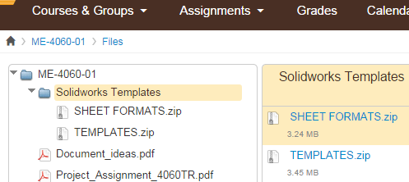

- In the SolidWorks System Options/File Locations window, add a link to the templates downloaded in Step 1.

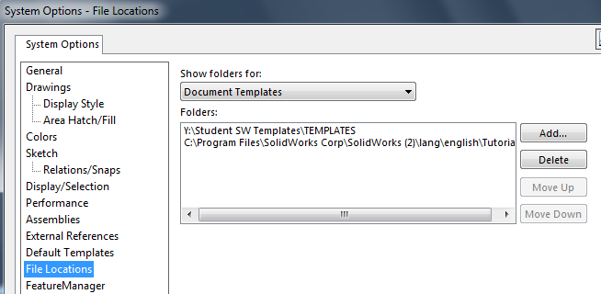

- When you start a new file, select the appropriate template. You may need to toggle from the Novice view to the Advanced view to see the templates.
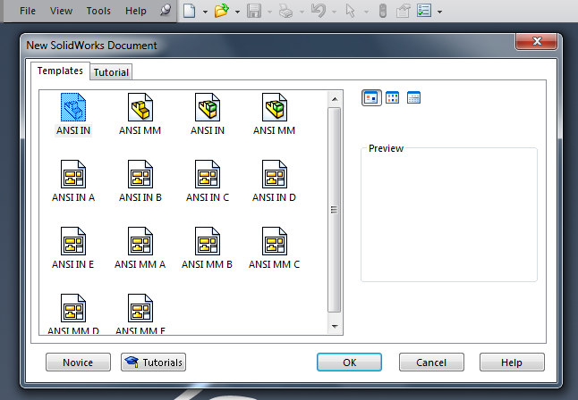

- In the File/Properties window fill in all of the Value/Text Expression blanks. Note that material, weight, volume, and density will be completed automatically once you have defined a material.

