Department of  Geology & Geophysics  Dept. 3006  1000 E. University Ave.  Laramie, WY 82071-2000  phone: (307) 766-3386  fax: (307) 766-6679  e-mail:  geol-geophys@uwyo.edu  web: www.uwyo.edu/geolgeophys  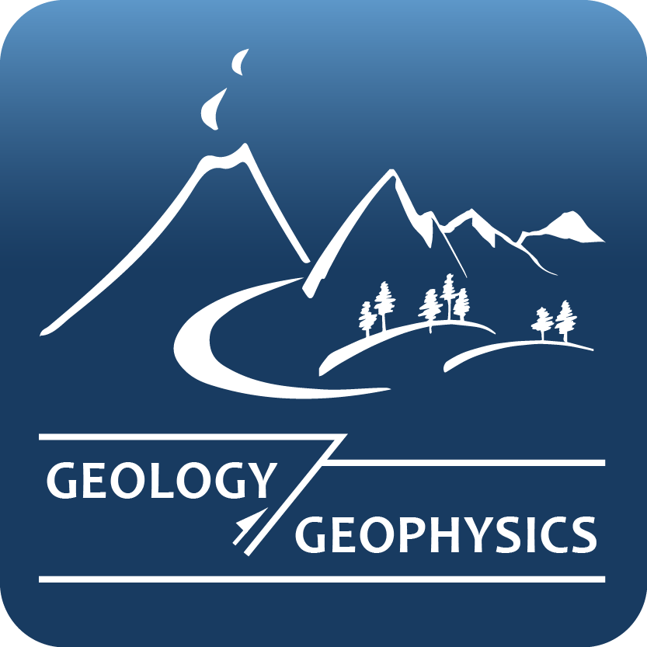 |  | January 29, 2014

