The University of Wyoming

Health History Screening Questionnaire (UWHHSQ)

Instructions: The researcher has a continuing obligation to determine risk stratification of each possible participant. If doubt about stratification level exists, safety should be the preeminent concern, the more conservative stratification should be used, e.g. moderate versus low or high versus moderate, and guidance from a qualified healthcare provider (MD, DO) should be sought. The following process must be used to determine risk stratification of each possible participant:

Step 1. Have potential participant’s complete the UW Health History Screening Questionnaire (UWHHSQ) UWHHSQ. The UWHHSQ is available on the Office of Research and Economic Development website. The completed UWHHSQ must be reviewed by the primary investigator and medical director for risk stratification (see below for additional information).

Step 2. The appropriate personnel (see below) should clarify any positive Reponses (if necessary) using Table 1 attached to the UWHHSQ.

Step 3. For positive responses on health history questionnaire, the appropriate personnel (see below) must use Table 2 attached to the UWHHSQ to determine which criteria applies. Each criteria scores one point in the various risk factor categories as listed. Total the number of points.

Step 4. Use Table 3 attached to the UWHHSQ to determine the risk classification of participants.

Step 5. Use Table 4 to determine whether you need a physician present during exercise testing.

Step 6. In order for MD or DO to act as medical director qualifications for the provider must be reviewed and approved by the IRB, including information such as current CV, practice experience, residency training, fellowship, or special courses for ECG reading and exercise testing. If the project includes any high risk subjects, provider must have training in acute medical issues such as myocardial infarction, stroke, or arrhythmias.

The University of Wyoming

Health History Screening Questionnaire (UWHHSQ)
Please complete thoroughly and accurately.

Date / /

Name: Ethnicity:
Address: City: State: Zip:
Date of Birth: / / Age: Biological Sex:_____________
Email: @ Phone #:
Emergency contact information: Name:_____________________________ Phone #: ________
Personal healthcare provider to contact in case of an emergency:
Name________________________________ Phone #: _________ City:_________________________________

CARDIOVASCULAR HEALTH HISTORY
(*Any “yes” answers, go to Table 2 for further information)
Have you ever been diagnosed with or had any of the following?
Heart Attack? ☐Yes ☐ No
Heart Surgery ? (such as Bypass/heart valve replacement) ☐ Yes ☐ No
Cerebrovascular accident (e.g. Stroke)? ☐ Yes ☐ No
Transient Ischemic Attack (TIA)? ☐ Yes ☐ No
Carotid Artery Disease? ☐ Yes ☐ No
Cardiac Catheterization? ☐ Yes ☐ No
Coronary Angioplasty/Stenting? ☐ Yes ☐ No
Pacemaker/Implantable Cardiac Device? ☐ Yes ☐ No
Irregular Heart Rate/Heart Rhythm Disturbance? ☐ Yes ☐ No
Atrial Fibrillation? ☐ Yes ☐ No
Heart Valve Disease? ☐ Yes ☐ No
Congestive Heart Failure? ☐ Yes ☐ No
Heart Murmur? ☐ Yes ☐ No
Heart Transplantation? ☐ Yes ☐ No
Congenital Heart Disease? ☐ Yes ☐ No

Have you ever experienced any of the following symptoms:

Ankle Swelling? ☐ Yes ☐ No
Chest discomfort with exertion? ☐ Yes ☐ No
Unreasonable breathlessness? ☐ Yes ☐ No
Dizziness, fainting, or blackouts? ☐ Yes ☐ No
Syncope (loss of consciousness)? ☐ Yes ☐ No
Hypoxia (low oxygen levels)? ☐ Yes ☐ No
Claudication with exercise (burning/cramping in legs)? ☐ Yes ☐ No

Have you been diagnosed with diabetes (Type 1 or Type 2), Pre-diabetes or other problems with blood sugar levels? ☐ Yes ☐ No
If yes, please note Type 1 or Type 2

If you answered yes to any of the above statements in this section, consult your physician or other appropriate health care provider before engaging in exercise. You may need to use a facility with a medically qualified staff.

CARDIOVASCULAR RISK FACTORS

Are you a male over 45 years old? ☐ Yes ☐ No
Are you a female over 55 years old? ☐ Yes ☐ No
Have you had a hysterectomy? ☐ Yes ☐ No
Have you had both of your ovaries surgically removed? ☐ Yes ☐ No
Are you postmenopausal? ☐ Yes ☐ No

Do you currently smoke or have you quit within the last
six months? ☐ Yes ☐ No

Is your blood pressure greater than 140/90 mm Hg? ☐ Yes ☐ No ☐ I Don’t Know
If known, what is your blood pressure? _____/ ____ mm Hg

Do you currently take blood pressure medications? ☐ Yes ☐ No
Do you currently take any medications for your heart? ☐ Yes ☐ No
Is your total blood cholesterol level greater than 200 mg/dl? ☐ Yes ☐ No ☐ I Don’t Know
Do you know your cholesterol level? ☐ Yes ☐ No If yes, Total Cholesterol
LDL
HDL
Triglycerides

Do you have a close blood relative who has suffered a heart attack
or had any kind of heart surgery before the age of 55 (for father
or brother) or age 65 (for mother or sister)? ☐ Yes ☐ No

Are you more than 20 pounds overweight? ☐ Yes ☐ No ☐ I Don’t Know

Are you physically inactive (i.e., do you get less than 30 minutes
of physical activity less than three times a week)? ☐ Yes ☐ No

Have you had a recent surgery (in the past 2 years)? ☐ Yes ☐ No

Have you had an exercise stress test, heart catheterization,
or echocardiogram? ☐ Yes ☐ No
If yes, please explain

To the best of your knowledge, is there any reason that might ☐ Yes ☐ No
make it unsafe for you to participate in exercise?

If you answered yes to two or more of the statements in the above section, you should consult your physician or other appropriate health care provider before engaging in exercise. You might benefit from using a facility with a professionally/medically qualified exercise program and staff.

To the best of my knowledge, the information I have provided above is an accurate assessment of my health and medical history.

Name of Participant Participant’s Signature Date

Name of Research Personnel Signature of Research Personnel Date

Please stop here. The remainder of this Health History Screening Questionnaire will be administered to you by one of our staff. (Refer to Table 1: Additional Questions to Clarify Positive Responses on Health History Questionnaire)

Research Personnel: Administer the remaining portion of the UWHHSQ (if applicable).
GENERAL MEDICAL HISTORY

Height: Weight: BMI (calculated):

Have you experienced acute illness or injury in the past 2 weeks? ☐ Yes ☐ No
Has a doctor ever told you not to participate in physical activity or vigorous physical activity?
☐ Yes ☐ No

Do you drink alcohol? ☐ Yes ☐ No
If yes, how many drinks per day or week?

Are you taking any prescription or over-the-counter medication? ☐ Yes ☐ No
If yes, what medication and what dosage?

Do you take any vitamins, supplements, or herbal/homeopathic medications? ☐ Yes ☐ No
If yes, what type and what dosage?

Has your body weight been stable over the past 6 months? ☐ Yes ☐ No
If no, please explain

Have you been on a recent diet or a prescribed diet? ☐ Yes ☐ No
If yes, please explain

Have you been diagnosed with asthma, exercise-induced asthma, reactive
airway disease, chronic obstructive pulmonary disease (COPD), or
any other respiratory disease? ☐ Yes ☐ No

If yes, please describe:

Do you use oxygen at any time of day or night? ☐ Yes ☐ No

Have you ever been diagnosed with cancer? ☐ Yes ☐ No
If yes, please describe when and what type:

Have you ever undergone a lymphectomy? ☐ Yes ☐ No If yes, please describe when and why?

Do you have musculoskeletal problems that limit your physical
activity such as walking? ☐ Yes ☐ No
Do you have concerns about your safety when you exercise or
exert yourself? ☐ Yes ☐ No

Have you ever experienced burning or cramping sensations in
your legs when walking short distances? ☐ Yes ☐ No

Do you have any other health problems, illnesses, diseases,
infections, surgeries, allergies, or hospitalizations? ☐ Yes ☐ No If yes, please explain

FAMILY HISTORY
Please check all that apply

Family Member | High Blood  Pressure | Diabetes  Type I or II | Heart Diseases | Comments
Mother |  |  |  | If yes, was it before the age of 65?  ☐ Yes ☐ No
Father |  |  |  | If yes, was it before the age of 65?  ☐ Yes ☐ No
Sibling |  |  |  | Gender: Age:
Sibling |  |  |  | Gender: Age:

FOR FEMALES ONLY:
Are you pre- , peri- or post- menopausal?

If premenopausal, are you using any form of contraception
(birth control) or hormone therapy for any reason? ☐ Yes ☐ No
If yes, why and what type?

If you are premenopausal:
Are you pregnant? ☐ Yes ☐ No ☐ I Don’t Know
Could you be pregnant? ☐ Yes ☐ No ☐ I Don’t Know
Are you trying to become pregnant? ☐ Yes ☐ No ☐ I Don’t Know

If you are peri- or postmenopausal:
For how long?

When was your last menstrual period? ________________________________________

Have you had a hysterectomy w/ or w/out ovary removal? ☐ Yes ☐ No
Have you had an oophorectomy without removal of your ☐ Yes ☐ No
uterus?

Are you currently taking any type of hormone replacement
therapy or using any form of contraception (birth control)? ☐ Yes ☐ No
If yes, what type? How long? Dosage

Name of Research Personnel Signature of Research Personnel Date
Table 1: Additional Questions to Clarify Positive Responses on the Health History Questionnaire

Signs or  Symptoms | Clarification/Significance
Pain; discomfort (or other angina equivalent) in the chest, neck, jaw, arms, or other areas that may result from ischemia | One of the Cardinal manifestations of cardiac disease, in particular coronary artery disease  Key features favoring an ischemic origin include the following:  - Character: constricting, squeezing, burning, “heaviness”, or “heavy feeling”  - Location: substernal, across midthorax, anteriorly; in one of both arms, shoulders; in neck, cheeks, teeth; in forearms, fingers in interscapular region  - Provoking factors: exercise or exertion, excitement, other forms of stress, cold weather, occurrence after meals  Key features against an ischemic origin include the following:  - Character: dull ache; “knifelike,” sharp, stabbing; “jabs” aggravated by respiration  - Location: in left sub mammary area; in left hemithorax  - Provoking factors: after completion of exercise, provoked by a specific body motion
Shortness of breath at rest or with mild exertion | Dyspnea (defined as an abnormally uncomfortable awareness of breathing) is one of the principal symptoms of cardiac and pulmonary disease. It commonly occurs during strenuous exertion in healthy, well-trained individuals and during moderate exertion in healthy, untrained individuals. However, it should be regarded as abnormal when it occurs at a level of exertion that is not expected to evoke this symptom in a given individual. Abnormal exertional dyspnea suggests the presence of cardiopulmonary disorders, in particular left ventricular dysfunction or chronic obstructive pulmonary disease.
Dizziness or Syncope | Syncope (defined as a loss of consciousness) is most commonly caused by a reduced perfusion of the brain. Dizziness and, in particular, syncope during exercise may result from cardiac disorders that prevent the normal rise (or an actual fall) in cardiac output. Such cardiac disorders are potentially life threatening and include severe coronary artery disease, hypertrophic cardiomyopathy, aortic stenosis, and malignant ventricular dysrhythmias. Although dizziness or syncope shortly after cessation of exercise should not be ignored, these symptoms may occur even in healthy individuals as a result of a reduction in venous return to the heart.  ___________________________________________________________________________
Orthopnea or paroxysmal nocturnal dyspnea | Orthopnea refers to dyspnea occurring at rest in the recumbent position that is relieved promptly by sitting upright or standing. Paroxysmal nocturnal dyspnea refers to dyspnea, beginning usually 2-5 hours after the onset of sleep, which may be relieved by sitting on the side of the bed or getting out of bed. Both are symptoms of left ventricular dysfunction. Although nocturnal dyspnea may occur in individuals with chronic obstructive pulmonary disease, it differs in that it is usually relieved after the individual relieves himself or herself of secretions rather than specifically by sitting up.
Ankle Edema | Bilateral ankle edema that is most evident at night is a characteristic sign of heart failure or bilateral chronic venous insufficiency. Unilateral edema of a limb often results from venous thrombosis or lymphatic blockage in the limb. Generalized edema (known as anasarca) occurs in individuals with the nephrotic syndrome, severe heart failure, or hepatic cirrhosis.
Palpitations or tachycardia | Palpitations (defined as an unpleasant awareness of the forceful or rapid beating of the heart) may be induced by various disorders of cardia rhythm. These include tachycardia, bradycardia of sudden onset, ectopic beats, compensatory pauses, and accentuated stroke volume resulting from valvular regurgitation. Palpitations also often result from anxiety states and high cardiac output (or hyperkinetic) states, such as anemia, fever, thyrotoxicosis, arteriovenous fistula, and the so-called idiopathic hyperkinetic heart syndrome.
Intermittent claudication | Intermittent claudication refers to the pain that occurs in a muscle with an inadequate blood supply (usually as a result of atherosclerosis) that is made worse by exercise. The pain does not occur with standing or sitting, is reproducible from day to day, is more severe when walking upstairs or up a hill, and is often described as a cramp, which disappears within 1-2 minutes after stopping exercise. Coronary artery disease is more prevalent in individuals with intermittent claudication. Patients with diabetes are at increased risk for this condition.
Known Heart Murmur | Although some may be innocent, heart murmurs may indicate valvular or other cardiovascular disease. From an exercise safety standpoint, it is especially important to exclude hypertrophic cardiomyopathy and aortic stenosis as underlying causes, because these are among the more common causes of exertion-related sudden cardiac death.
Unusual Fatigue or shortness of breath with usual activities | Although there may be benign origins for these symptoms, they also may signal the onset of or change in the status of cardiovascular, pulmonary, or metabolic disease.
These signs or symptoms must be interpreted within the clinical context in which they appear because they are not all specific for cardiovascular, pulmonary, or metabolic disease.

Taken from the GUIDELINES FOR EXERCISE TESTING by the American College of Sports Medicine (ACSM). www.acsm.org

Risk Factors | Defining Criteria | Points
Age | Men≥45 yr.; Women≥55 yr
Family History | Myocardial Infarction, coronary revascularization, or sudden death before 55 yr in father or other male first-degree relative or before 65 yr in mother or other female first-degree relative
Cigarette  Smoking | Current cigarette smoker or those who quit within the previous 6 mo. Or exposure to environmental tobacco smoke
Sedentary  Lifestyle | Not participating in at least 30 min of moderate intensity, physical activity (40% -<60% VO2R) on at least 3 d of the week for at least 3 mo
Obesity | Body Mass index ≥30 kg m-2 or waist girth> 102 cm (40in) for men and > 88cm (35 in) for women
Hypertension | Systolic Blood Pressure ≤140mm Hg or 150mm Hg (depending on age) and/or diastolic ≥90mm Hg, confirmed by measurements on at least two separate occasions, or on antihypertensive medication
Dyslipidemia | Low-density lipoprotein (LDL) cholesterol ≥130 mg dL-1 (3.37 mmol L-1) or high-density lipoproteinB (HDL) Cholesterol <40 mg dL-1) (1.04 mmol l-1) or on a lipid-lowering medication. If total serum cholesterol is all that is available, use ≥200 mg dL-1 (5.18 mmol L-1)
Prediabetes | Impaired fasting glucose (IFG)= fasting plasma glucose ≥100 mg dL-1 (5.55 mmol L-1) and ≤125 mg dL-1 (6.94 mmol L-1) or impaired glucose tolerance (IGT) = 2 h values in oral glucose tolerance test (OGTT)≥ 140 mg dL-1 (7.77 mmol L-1) and ≤ 199 mg dL-1 (11.04 mmol L-1) confirmed by measurements on at least two separate occasions
Table 2- Atherosclerotic Cardiovascular Disease (CVD) Risk Factors and Defining Criteria
*Note: Each risk factor is 1 point. For additional information, please see page 1 (Instructions).

____________
Total Points

Taken from the GUIDELINES FOR EXERCISE TESTING by the American College of Sports Medicine (ACSM). www.acsm.org
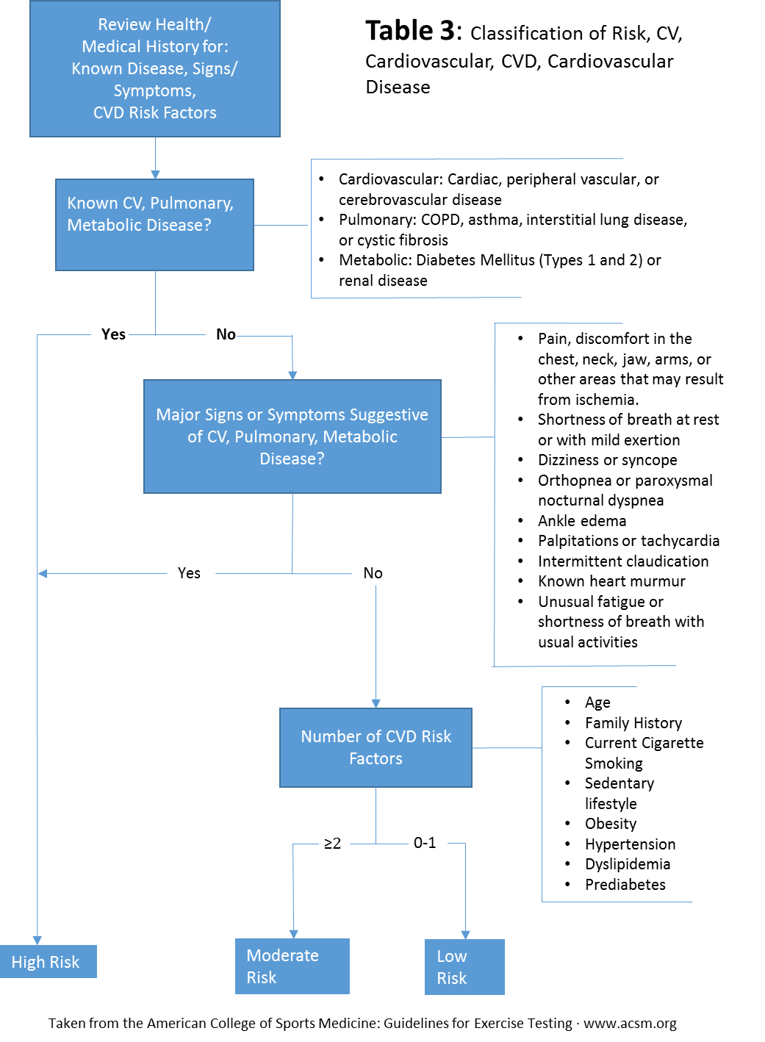Table 4- Determining whether you need a physician present during testing
Risk Classification
Definitions
Submaximal Exercise: Moderate intensity exercise; Moderate intensity exercise; ≤ 85% of age-predicted maximum heart rate.
Maximal Exercise: Vigorous intensity exercise; ≥ 85% of age-predicted maximum heart rate.
Not Recommended: Reflects the notion a medical examination, exercise test, and physician supervision of exercise testing are not recommended in the pre-participation screening; however, they may be considered when there are concerns about risk, more information is needed for the ExRx, and/or are requested by the patient or client.

Recommended: Reflects the notion a medical examination, exercise test, and physician supervision of exercise testing are recommended in the pre-participation screening process.

(Taken from the GUIDELINES FOR EXERCISE TESTING by the American College of Sports Medicine (ACSM). www.acsm.org)

If the subject has had an acute cardiovascular problem within one year of testing such as myocardial infarction, stroke, cardiovascular surgery, etc. then medical clearance from a private physician is required for maximal and submaximal exercise.
Pre-project exercise testing may be required depending on a full evaluation by the Medical Director and PI.

High Risk
Symptomatic
2 or more risk factors

MD Supervision of
Exercise Test if Done?
Submax – Yes
Max - Yes

Exercise Test Required
Before Exercise?
Submax – No
Max- No

Exercise Test Required
Before Exercise?
Submax – No
Max- No

Medical Clearance Required
Before Exercise?
Submax – No
Max –No
*
MD Supervision of
Exercise Test if Done?
Submax – No
Max - No

Medical Clearance Required
Before Exercise?
Submax - No
Max - No
Moderate Risk
Asymptomatic
2 or More Risk Factors

MD Supervision of
Exercise Test if Done?
Submax – No
Max - No
Exercise Test Required
Before Exercise?
Submax – No
Max- No
Medical Exam Required
Before Exercise?
Submax -No
Max - No
Low Risk
Asymptomatic
0-1 Risk Factors

